MATH 211 Signature Assignment
Question 1
a) The population for this study will include 9 people selected using systematic random sampling method from my course mates. I emailed a total of 30 classmates, and received a total of 27 responses, I systematically recorded height and shoe size from every third respondent. The sample accurately represents my population because the response rate was high and random sampling was used to select variable data for the study.
b)
 | Person 1 | Person 2 | Person 3 | Person 4 | Person 5 | Person 6 | Person 7 | Person 8 | Person 9
Height (inches) | 55 | 55 | 60 | 60 | 63 | 65 | 66 | 70 | 72
Shoe size | 6 | 6 | 7 | 7 | 7 | 8 | 9 | 10 | 11

Question 2
Alpha à is 0.01
- sample mean $\overline{x}=\frac{\sum{xi}}{n}=\frac{567}{9}=63$
standard deviation s_{x} $=\frac{\sqrt{\sum{(x-\overline{x})^2}}}{n-1}=6.0622$
- sample mean $\overline{y}=\frac{\sum{yi}}{n}=\frac{1207}{9}=134.1111$
standard deviation s_{y} $=\frac{\sqrt{\sum{(y-\overline{y})^2}}}{n-1}=$ 22.401
- 99% Confidence Interval $=\overline{x}±t\frac{a}{2},df*\frac{Sx}{\sqrt{n}}$
Lower bound 56.1678
Upper bound 69.6100
We can be 99% confident that the true population mean for height is between 56.1678 and 69.61
- 99% Confidence Interval $\overline{y}±t\frac{a}{2},df*\frac{Sy}{\sqrt{n}}$
Lower bound 5.9161
Upper bound 9.8617
We can be 99% confident that the true population mean for shoe size is between 5.9161 and 9.8617

Question 3
a) Here we have to test the claim that the mean height of the population is different from 64 inches or not. For this we decide to use one sample T test because we don’t have the population standard deviation.
Therefore, the hypothesis for the study is -
Null hypothesis H₀: µ = µ₀ vs Alternative hypothesis H₁: µ ≠ µ₀
Where µ₀ is the true population mean, in our case 64
b) Test statistic, T is given by 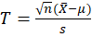 where s is 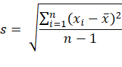
Inputting the values into the formula, we find
T = - 0.49
P value= 0.634
c) Since the p-value is greater than significance value 0.01 we fail to reject the null hypothesis. Therefore, conclude that the mean height of the sample is not different from the population mean of 64
Question 4
- Scatterplot
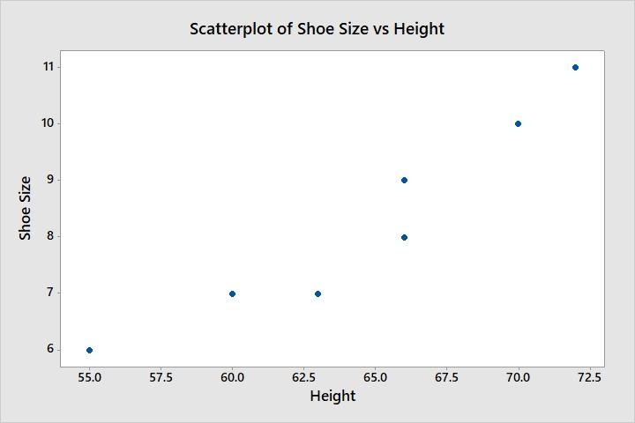
- R (correlation coefficient) = 0.96573241
The correlation coefficient is positive and close to 1 meaning that there is a strong correlation between shoe size and height of a person.
c) Regression equation from StatCrunch
Shoe size = -9.9376923 + 0.28346154 *Height

Question 5
The process started with data collection from different respondents using systematic sampling. The step was critical to ensure that bias is eliminated and the sample data collected fairly represents the population. The collected data was then used to develop a statistical analysis using T-test and linear regression. I learnt that the results of a statistical process depend on the quality of the data collected. In future when reading about statistics, I will be keen to ensure that the data collection and analysis methods represent the true population without bias.

